“All Star Year, One Family, One Vision & One School”
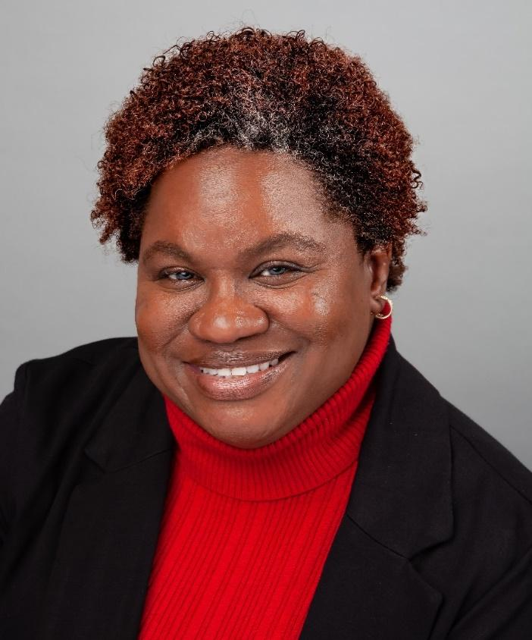 |  | Welcome to health education. What an amazing journey we get to embark on together! You will not believe how much your child will grow this year. I am requiring your child to bring eagerness, self-disciplined behavior, and a participating heart to class. I have so much planned, and I cannot wait to get to know you and your family.  I am an introverted Christian who is the youngest to three sisters who are educators. This year marks my 22nd year in education. I have taught Pre-Kindergarten through Eighth grade. I love learning and researching. I have the following degrees:  - Bachelor of Science in Health and Physical Education from Albany State University in Albany, Ga.  - Master of Education in Instructional Technology from Troy University in Troy, Alabama  - Educational Specialist in Administration from Cambridge College in Cambridge, Massachusetts.
Class Schedule
Period | Time | Grade Level | Location
1st or 2nd | 11:10-12:25 | 7th | Room 229
3rd or 4th | 12:45-2:00 | 6th | Room 126
5th or 6th | 2:45-4:05 | 8th | 209

